**Tutorial week 11**

A manufacturer produces a digital filter operating at 10kHz sampling frequency. The filter has a frequency response as indicated in Fig Q1. This shows the 2-sided magnitude and 2-sided phase plots of the frequency response of the digital filter. The following continuous signal $x(t)$ is sampled using a sampling frequency *fs= 10kHz* to produce a sampled signal $x[n].$

$$x(t)= 4 + cos(5000πt) + 2sin(2500πt)$$

Using the frequency response curves given in Fig 1 determine the steady state output of this DSP device due to the input signal $x[n].$

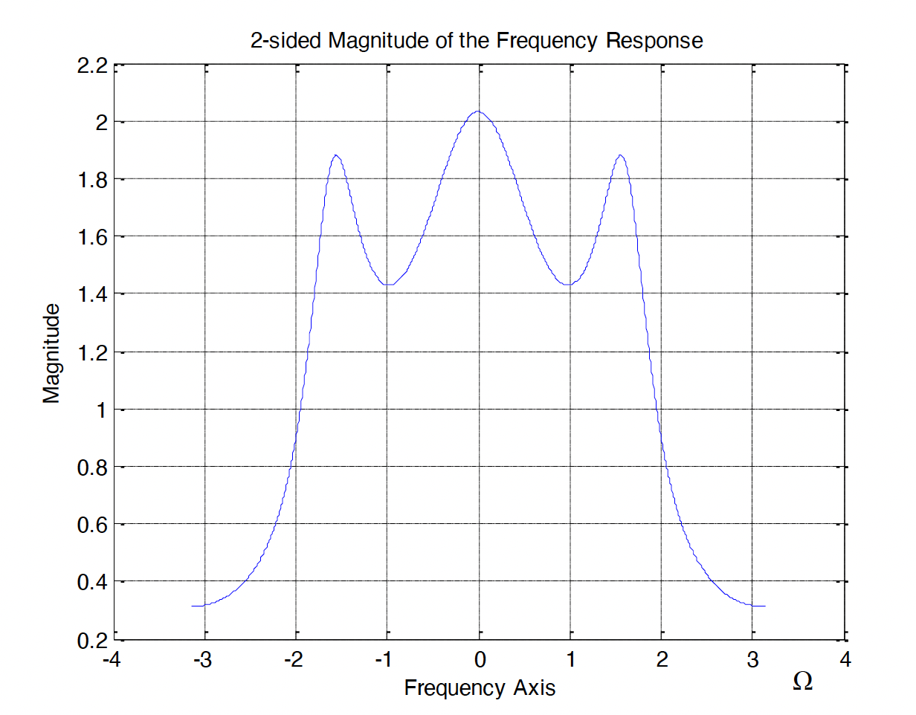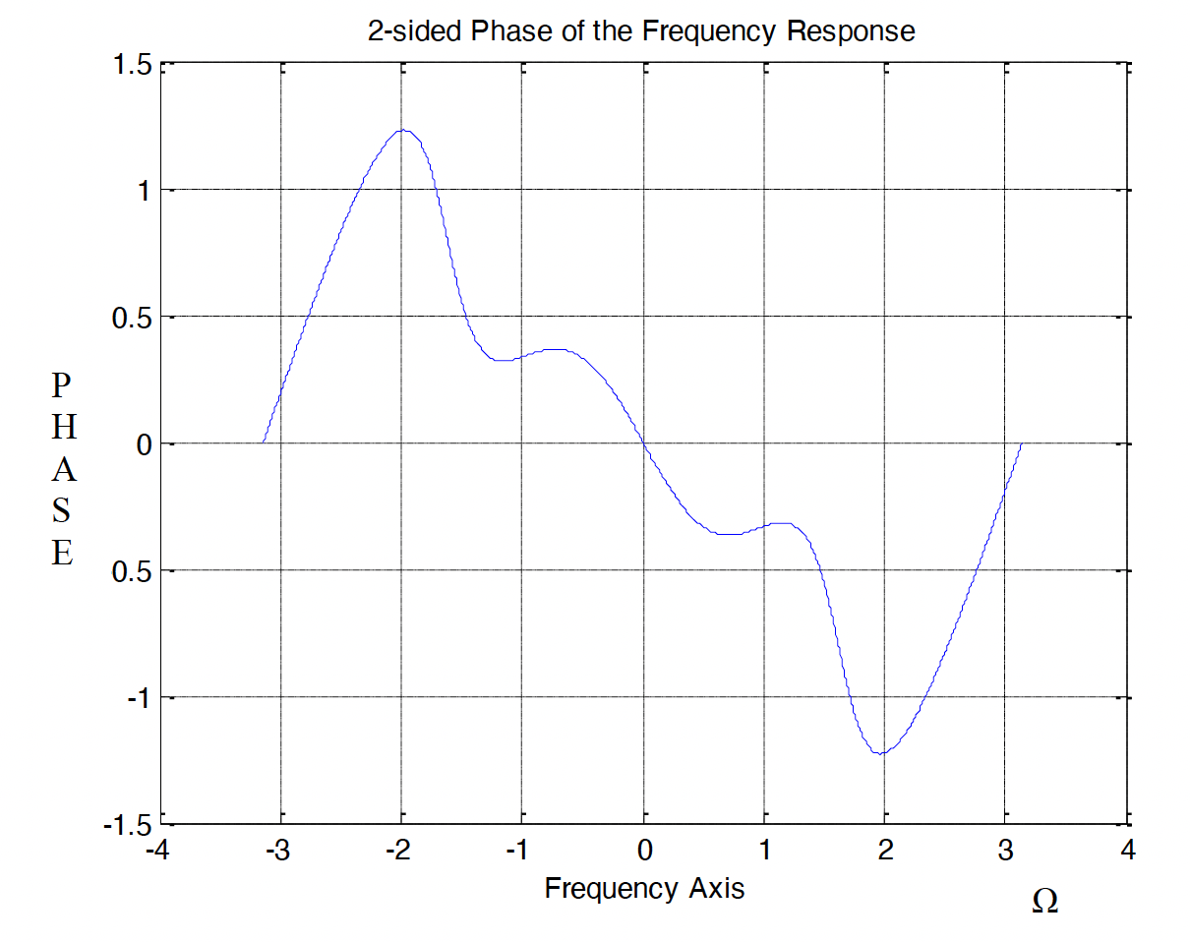

**(b)**

A speech signal $s_{s}[n]$ is sampled with a sampling frequency of 16kHz, a music signal $s_{m}[n]$ is sampled at 44.1kHz and an audio signal $s_{a}[n]$ is sampled at 48kHz. These signals are to be mixed (added together) and the resulting signal is to be filtered by a filter that has a sampling frequency of 64kHz. Design a suitable multirate DSP system that will produce the desired output. In your design clearly indicate the specifications of each sub unit.